please contact us :
E-mail : lina@shengrungroup.com

Wechat : +8617852856151
Facebook :+8617852856151

Linked in : lina@shengrungroup.com

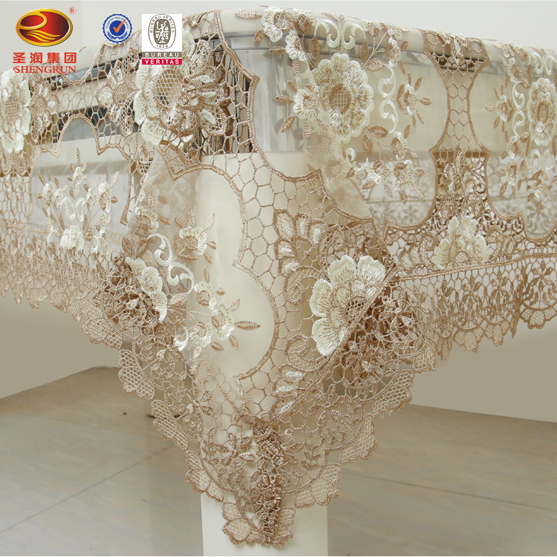
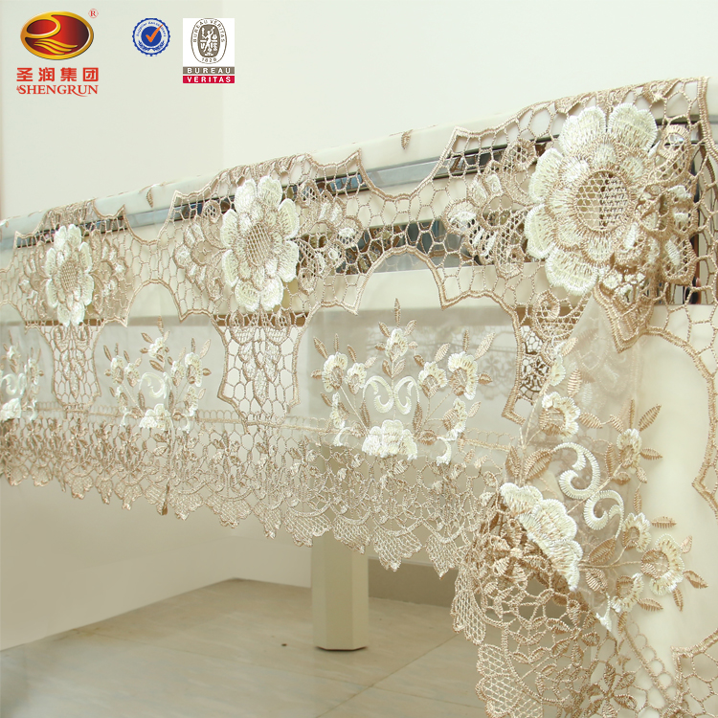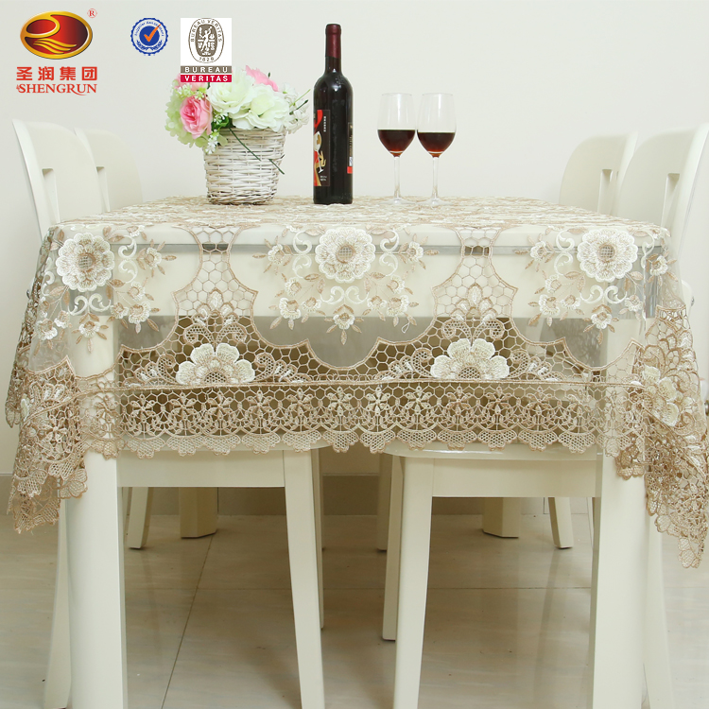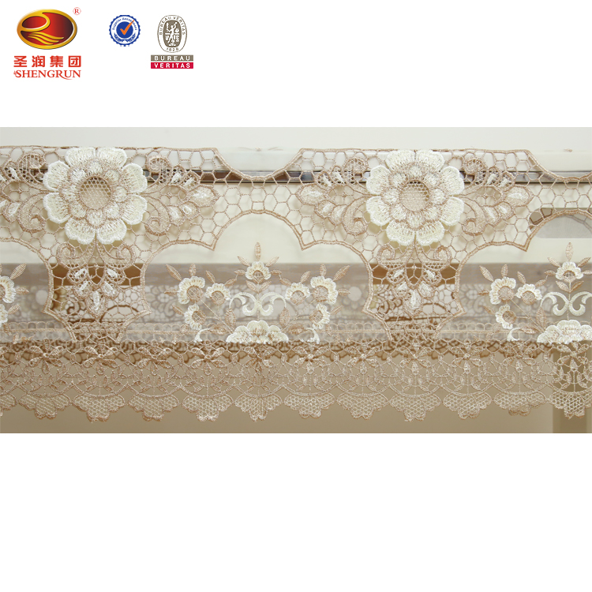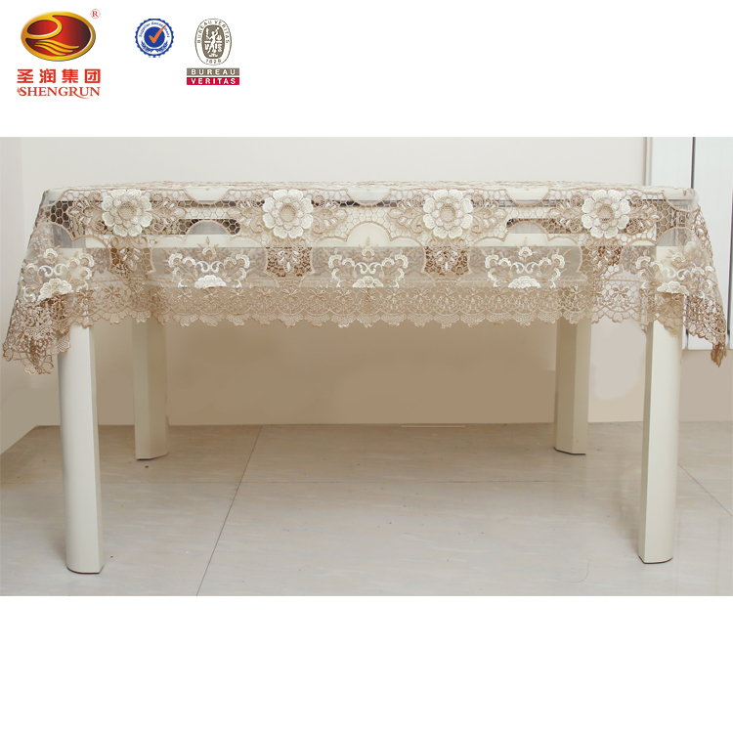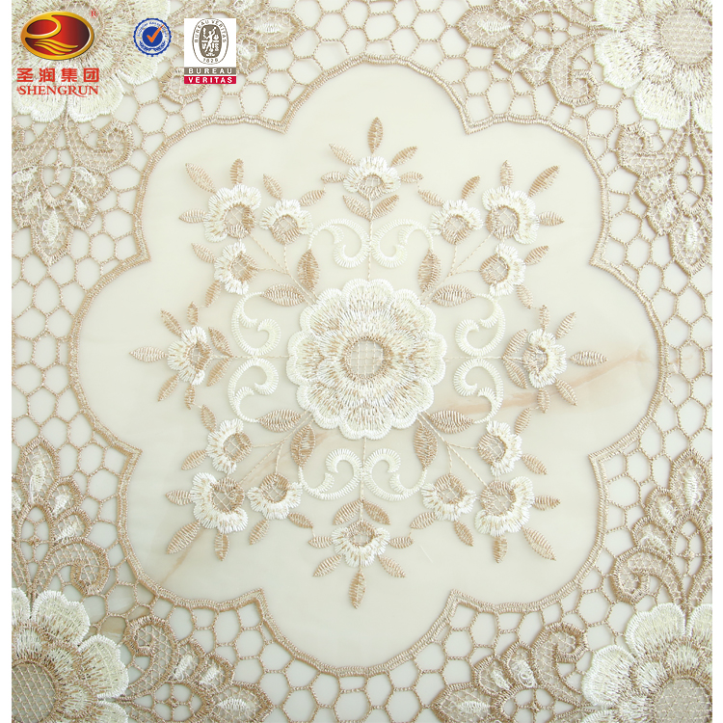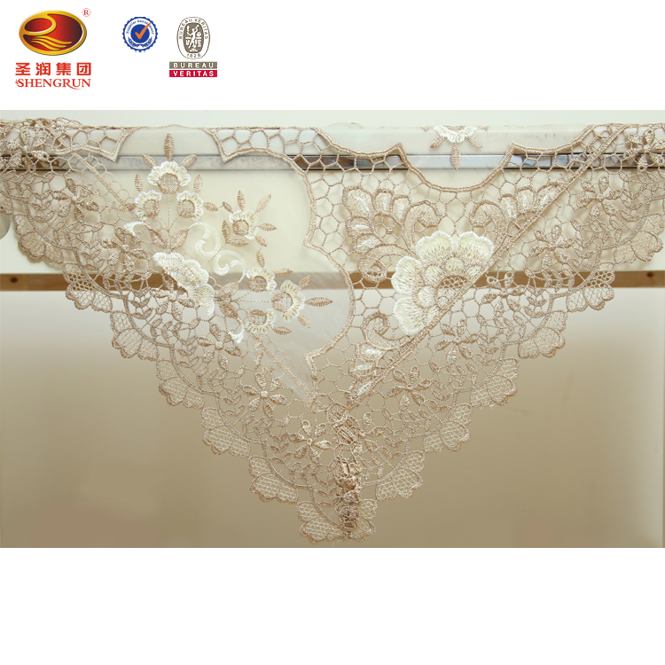
Material : organdy and polyester
Size : 12*18 16*36 16*45 16*54 16*72 54*72 72*90 72*108 72*126
Pattern Type:Geometric
is customized: Yes
Pattern:Embroidered
Technics:Machine embrodiered
Shape:Square/ round /Rectangle /Oval
Feature:Disposable, Cheap cost with high quality Fast delivery time
Use:Banquet, Home, Hotel, Outdoor, Party, Wedding
Place of Origin:Shandong, China (Mainland)
Brand Name:ShengRun
Color:Khaki
Quality:nice quality
Usage:Decoration
MOQ:100pcs
Delivery:To the door
Packaging & Delivery
Selling Units:Single item
Single package size: 45X20X2 cm
Single gross weight:1.0 KG
Lead Time :
Quantity(Piece) | 1 - 100 | >100
Est. Time(day) | 60 | To be negotiated

Shandong Shengrun Textile Co.,Ltd was established in June 2000 with a registered capital of 100 million yuan. The company covers an area of about 260 acres, with a production and storage workshop of 75,000 square meters. The office building and research center and other construction areas are about 18,000 square meters. The total investment is 350 million. Shandong Shengrun Textile Co.,Ltd is a foreign trade textile enterprise with self-support import and export rights. The company has five production branches, namely embroidery branch, spinning branch, towel branch, weaving branch and home textile. The branch has two import and export marketing companies. The company has 18 sets of Japanese WEMS computer shuttle embroidery machines and more than 50 high-efficiency multi-head computer embroidery machines. The company is China's largest production base of functional acrylic blended yarn, and is also the first “National Functional Acrylic Blended Yarn R&D and Production Base” in China. The company has a provincial enterprise technology center, a provincial technology research and development center, and three City-level R&D platform, more than 200 various R&D technicians, the company has obtained hundreds of patents and innovations. It produces 5 million meters of embroidery cloth and 100,000 pieces of embroidered tablecloth every month. The products are sold well in dozens of countries such as Europe, North America, South America, Africa, Southeast Asia and the Middle East. Shandong Shengrun Textile Co.,Ltd has been continuously expanding and extending, and has formed a complete industrial chain integrating the production of embroidered tablecloths, acrylic yarns and household textile products at home and abroad. Among them, the tablecloth embroidering series brings together the wisdom and inspiration of many domestic masters. Each piece of tablecloth is produced by the designer's fine craftsmanship, and each piece is an art piece worthy of collection.

